**Hosting different webpages on DNS**

**Architecture:**

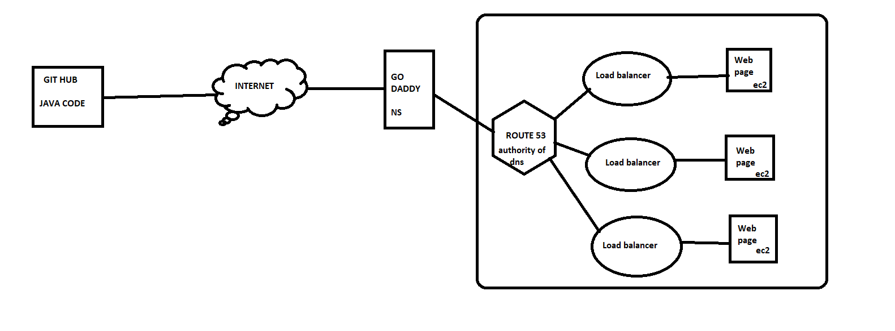

**Create three instance and clone the code from git hub:**

Install git and configure the account and clone the repo from github

And confg the security group with req port (8080-tomcat, 80-http,22-ssh)

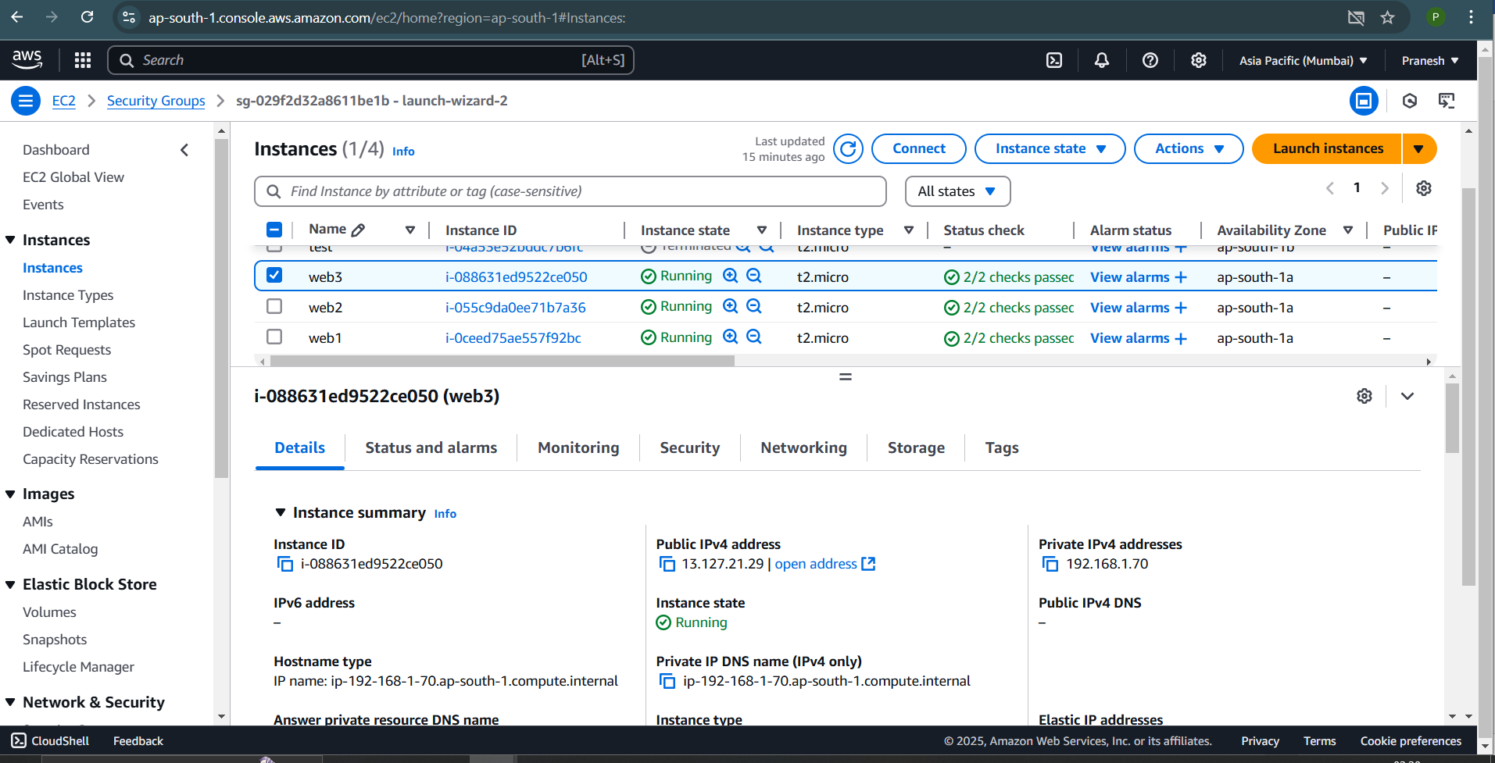

For java web page install req package:

apt install -y openjdk-17-jdk tomcat10

clone the repo from github and land in the path /var/lib/tomcat10/webapps/ROOT/

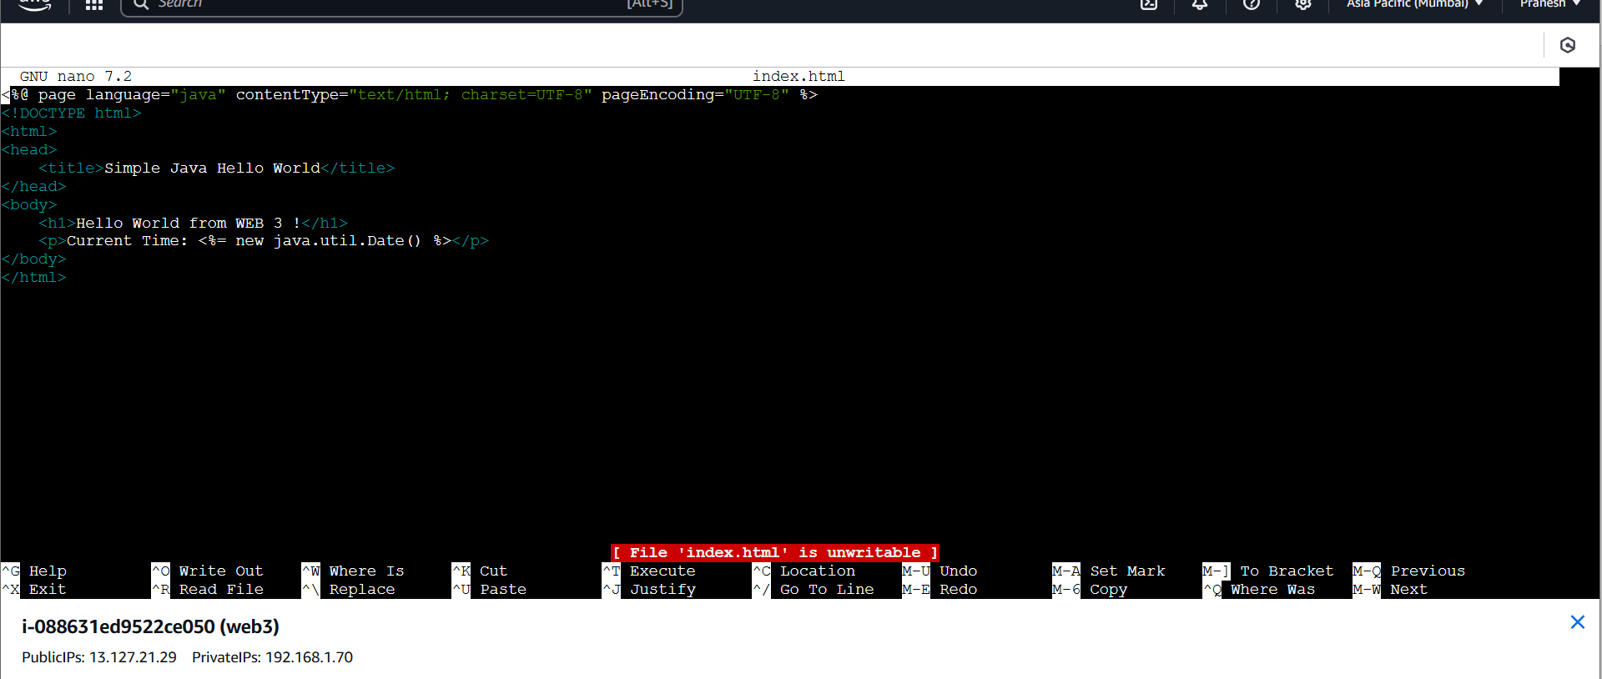

restart the tomcat10

Now connect the Instances with the Load balancer:

Conf the load balancer with correct listing port(80) and instance port(8080) and health check path /

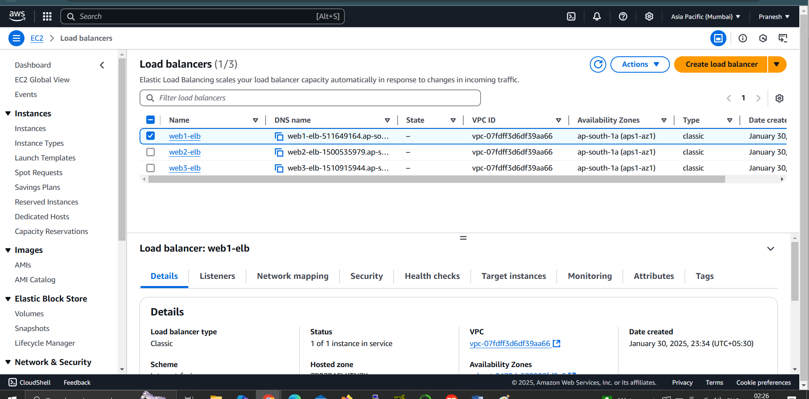

Check the health status of the instance.

Now have a domain name from dns provider (go daddy, hostinger)

Launch the Hosted zone on Route 53 and give the domain name:

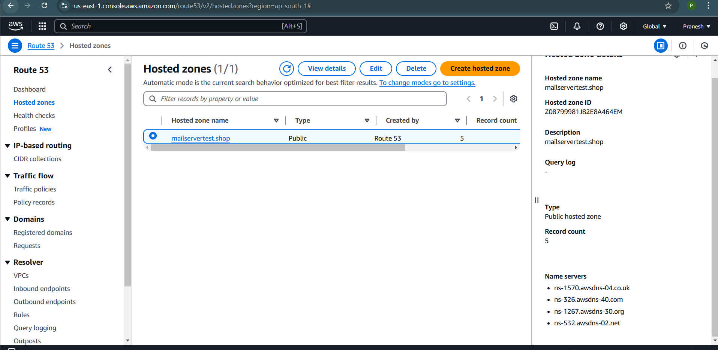

Copy the Name server from the Aws and add it to the custom name server of dns provider

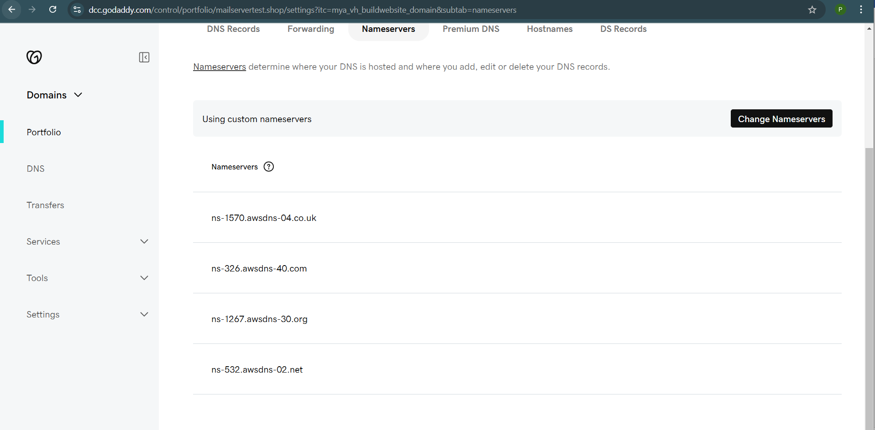

Now in the hosted zone create A record (it contains ip’s)

Map the ip of each Load balancer dns to the A record with record name .

Get the ip of dns by nslookup:

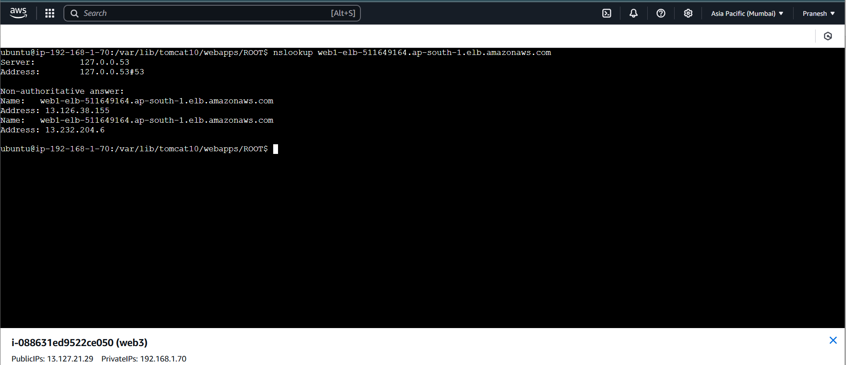

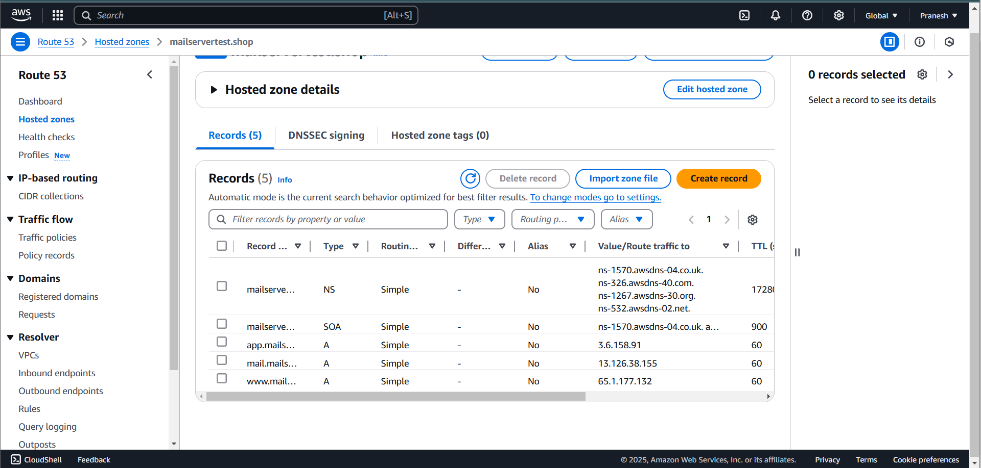

Now with one DNS it loads to the three diff load balancer and gives the backend webserver web pages.

